|  |  |
| --- | --- |
| **As a** | Registered user of <https://FinTrust.com> |
| **I want** | to be able to access my Account Summary Page |
| **So that** | I can view my Current Balance. |
| **Acceptance Criteria** | 1. As a registered user of <https://FinTrust.com>, System shall allow users to access their Account Summary Page(refer Appendix 2: ‘Account Summary’ Page Wireframe and Appendix 3: ‘Account Summary’ Page Data Table) 2. System allows user to view their Current Balance. 3. On click of ‘Check your Balance’ Command button, system allows users to view their Realtime Balance Amount. 4. On click of ‘View Nominee’ Hyperlink, system allows users to view Nominee Details. 5. On click of ‘Transfer Funds’ Command button, System navigates the user to the Transfer Funds Page. 6. On click of ‘Transaction History’ Command button, System navigates the user to the Transaction History Page. 7. On click of ‘View Statements’ Command button, System navigates the user to the View Statements Page. 8. On click of ‘Profile Page’ Icon, system navigates the user to the Profile Page. 9. System should also display the following account Holder details on the Account Summary Page:   - Account Number  - Account Holder Name  - IFSC Code  - MMID  10. System should also display the Active status of the account. |

**Appendix 1:** ‘Login’ Process Flow

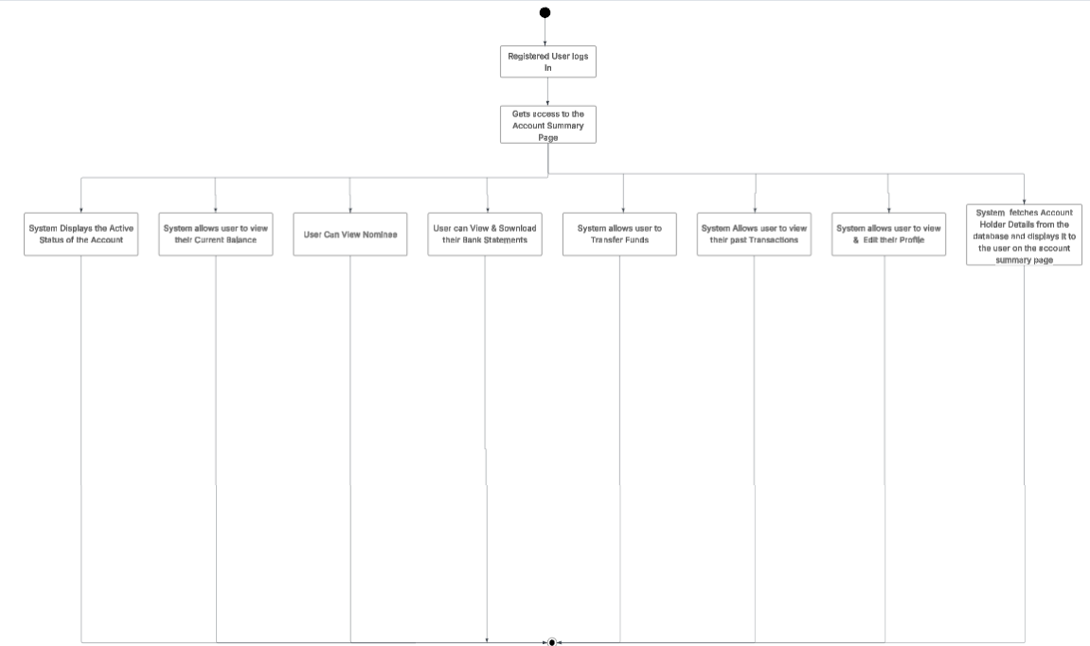

**Appendix 2:** Display ‘Account Summary’ Page wireframe

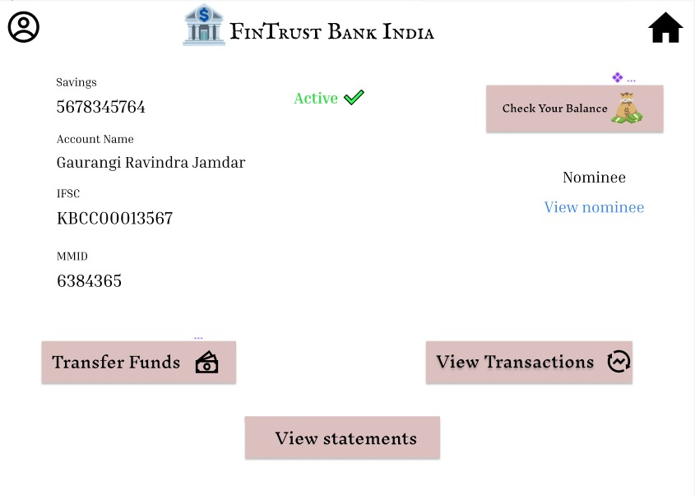

**Appendix 3:** Data Table for ‘Account Summary’ Page

|  |  |  |  |  |  |
| --- | --- | --- | --- | --- | --- |
| **ID** | **Field Name** | **Field Type** | **Content** | **Required Field?** | **Notes** |
| 1 | FinTrust Bank India | Text | N/A | N/A | Page Title |
| 2 | Check Your Balance | Command Button | N/A | N/A | On click, display the Realtime Account Balance. |
| 3 | Transfer Funds | Command Button | N/A | N/A | On click, System navigates the user to the transfer funds page. |
| 4 | View Statements | Command Button | N/A | N/A | On click, System navigates the user to the View Statements Page. |
| 5 | View Transactions | Command Button | N/A | N/A | On click, System navigates the user to the Transaction History Page. |
| 6 | View Nominee | Link | N/A | N/A | On click, displays the Nominee details. |
| 7 | Account Number | Text | Numeric | N/A | System Fetches the account number from the database and displays it on the account summary page. |
| 8 | Account Holder Name | Text | Char | N/A | System Fetches the account Holder Name from the database and displays it on the account summary page. |
| 9 | IFSC Code | Text | Alphanumeric | N/A | System Fetches the IFSC Code from the database and displays it on the account summary page. |
| 10 | MMID | Text | Numeric | N/A | System Fetches the MMID from the database and displays it on the account summary page. |
| 11 | Account Status | Text | Active/InActive | N/A | System shall display the account status. |
| 12 | Profile Page Icon | Icon/Button | N/A | N/A | On click, system shall navigate the user to the My profile page. |